**PRACTICAL 1**

**Aim: Create new flutter project using each of the following:**

**1. Terminal**

**2. VS Code**

**3. Android Studio**

**• Run the above created flutter project in Android emulator using:**

**1. Terminal**

**2. VS Code**

**3. Android Studio**

**Steps:**

**Creating a New Flutter Project**

#### Using Terminal

1. Open the terminal.
2. Navigate to the directory where you want to create your project.
3. Run the following command to create a new Flutter project: flutter create

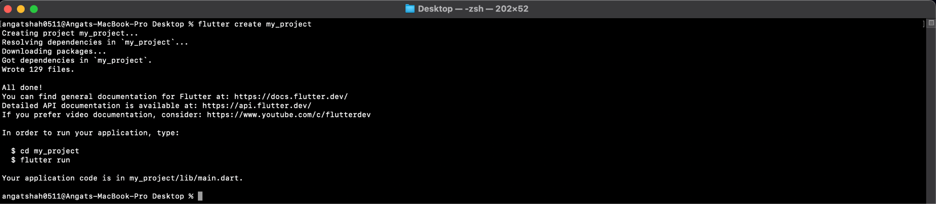

Using VS Code

1. Open the Command Palette with ‘cmd + Shift + P’.
2. Type ‘Flutter : New Project’ and select it. Follow the prompts to specify the project name and location.
3. VS Code will automatically open the new Project Directory.

Using Android Studio

1. Open Android Studio
2. Click on ‘Start a new Flutter Project’ on the Welcome Screen. Choose ‘Flutter Application’ and click ‘Next’.
3. Configure the Project. Fill in the required fields (Project name, Project location, etc.). Click ‘Finish’ to create and open the project.

**Run the Flutter Project in Android Emulator**

Using Terminal

1. Open the terminal.
2. Start the iOS Emulator
3. Run the project using the following command: flutter run

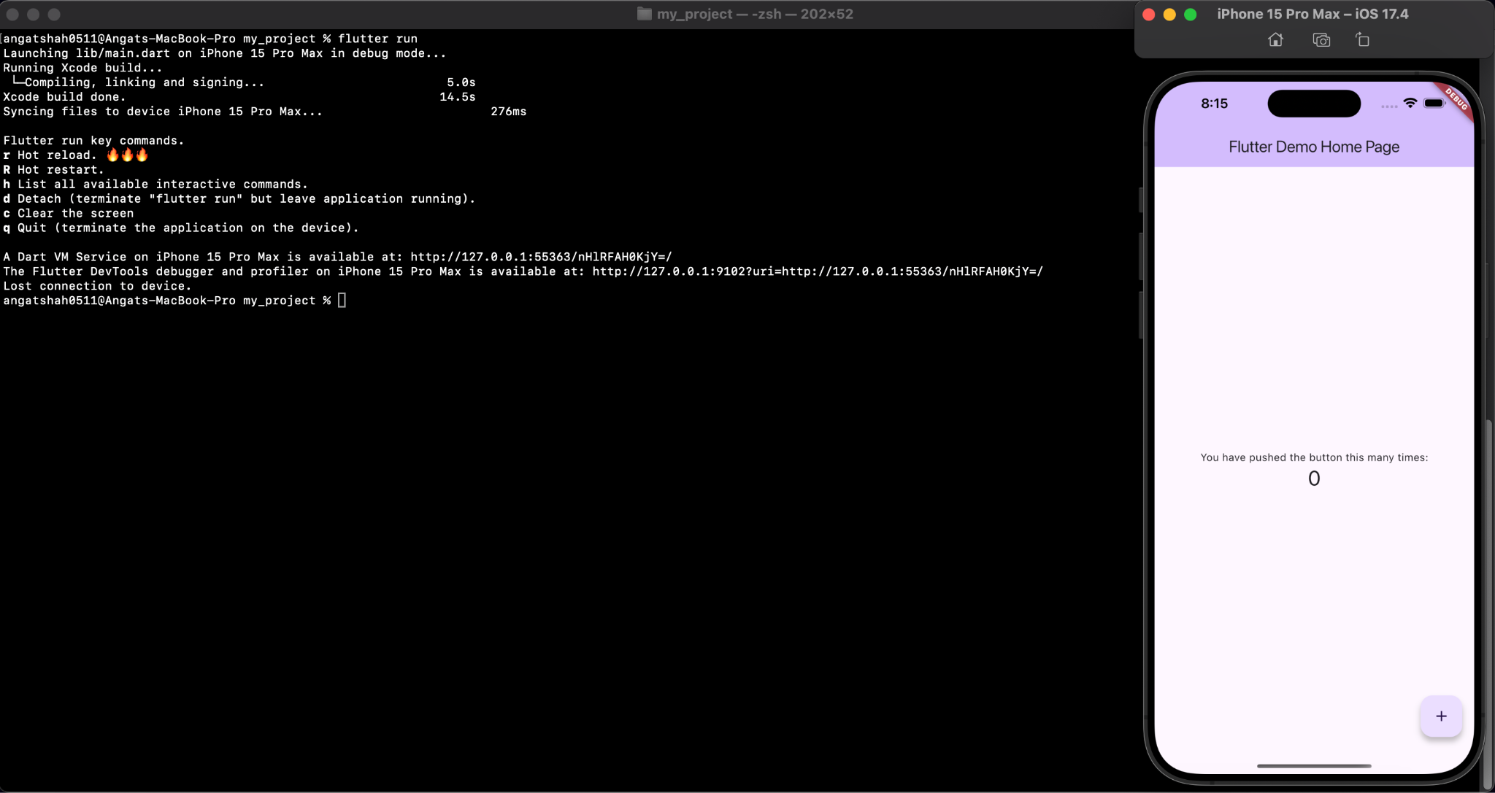

Using VS Code

1. Open the Debug Panel by clicking on the Run and Debug icon on the sidebar or press ‘cmd + Shift + D’.
2. Select Device
3. Run the Project by clicking ‘F5’ to start debugging, which will build and run your Flutter app on the selected emulator.

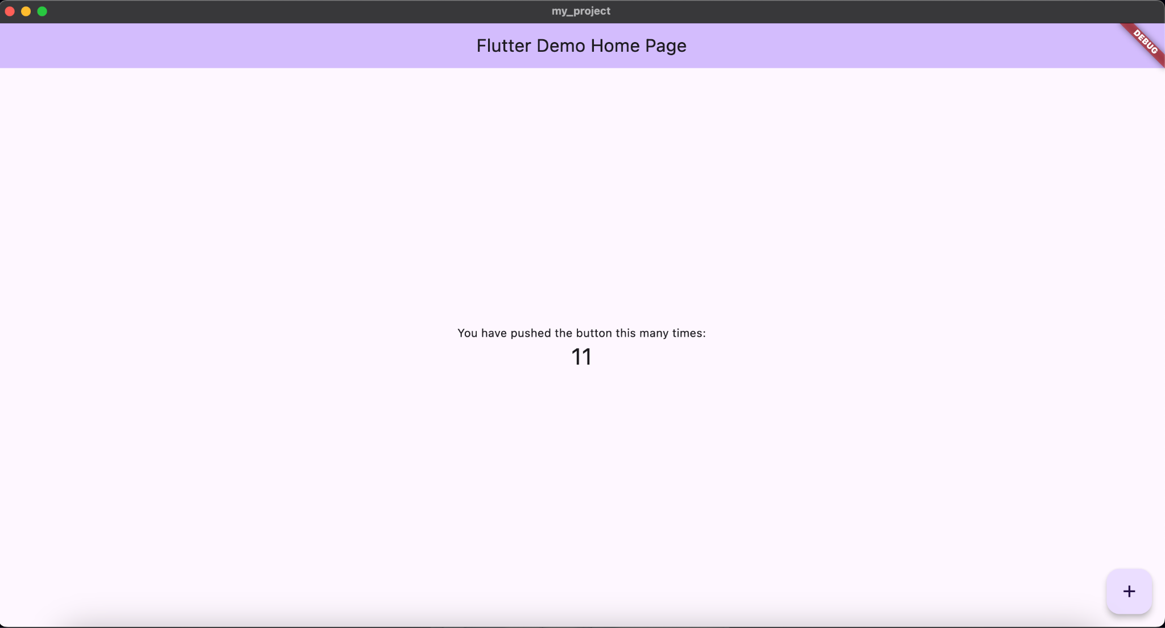

Using Android Studio

1. Open Android Studio
2. Start the Android Emulator. You can start the emulator by going to ‘Tools’ > ‘AVD Manager’, and then clicking on the play button next to your emulator.
3. Run the Flutter Project : Click on the green run button (play icon) in the top-right corner of the IDE.

